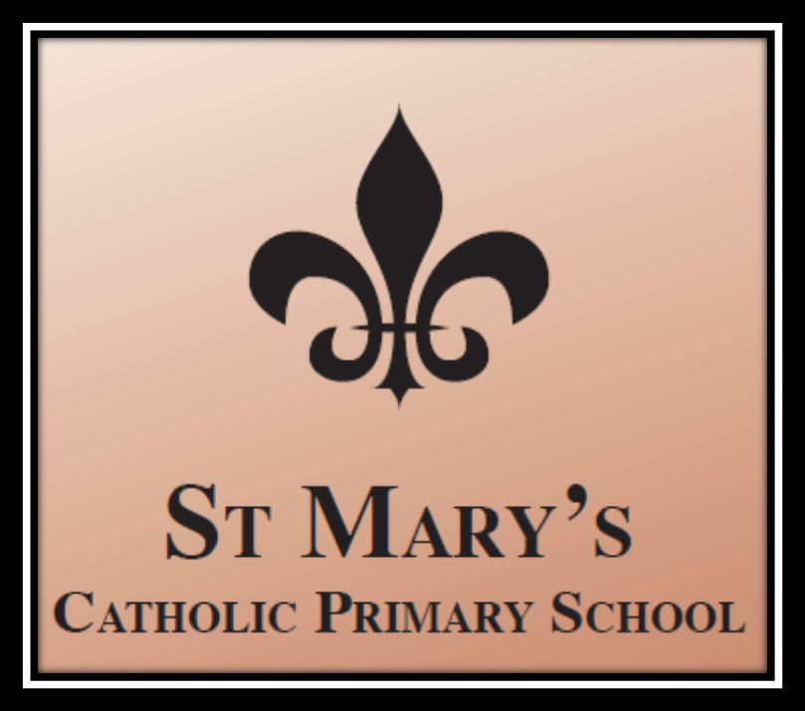

Catch-up Funding September 2020 (Under continual review)

What catch-up funding is for?
The government announced £1 billion of funding to support children and young people to catch up lost time after school closure. This is especially important for the most
vulnerable and disadvantaged backgrounds. St Mary’s Catholic Primary School will make every effort to support disadvantaged pupils with their learning. For the purposes of this plan, the term disadvantaged goes beyond the Government’s definition of those eligible for Free School Meals or Pupil Premium and includes those who may struggle to
access remote education whilst not attending school (i.e. pupils facing difficult circumstances in the home environment of those with limited or no access to technology
at home).
The school allocation is calculated on a per pupil basis; mainstream schools will get £80 for each pupil in from reception to year 11 inclusive.
Schools will get funding in 3 tranches:
Autumn 2020 – this is based on the latest available data on pupils in mainstream schools and high needs place numbers in special, AP, hospital schools and special
schools not maintained by a local authority.
Early 2021 – based on updated pupil and place data. This payment will also take account of the initial part payment made in Autumn 2020 so that schools will receive a
total of £46.67 per pupil or £140 per place across the first 2 payment rounds.
Summer 2021 term - a further £33.33 per pupil or £100 per place.
Schools should use this funding for specific activities to support their pupils to catch up for lost teaching over the previous months. School leaders must be able to show
they are using the funding to resume teaching a normal curriculum as quickly as possible following partial or full school closure. Governors should scrutinise schools’
approaches to catch-up from September 2020, including their plans for and use of catch-up funding. This should include consideration of whether schools are spending
this funding in line with their catch-up priorities, and ensuring appropriate transparency for parents.

What should the funds be used for?  Schools should use this funding for specific activities to support their pupils to  catch up for lost teaching over the previous months, in line with the guidance  on curriculum expectations for the next academic year.  Schools have the flexibility to spend their funding in the best way for their  cohort and circumstances.  To support schools to make the best use of this funding, the Education  Endowment Foundation (EEF) has published a coronavirus (COVID-19) support  guide for schools with evidence-based approaches to catch up for all students.  Schools should use this document to help them direct their additional funding  in the most effective way | The EEF advises the following support strategies:  Teaching  High quality teaching for all  Effective diagnostic assessment  Supporting remote learning  Focusing on professional development  Targeted academic support  High-quality one to one and small group tuition  Teaching Assistants and targeted support  Academic tutoring  Planning for pupils with Special Educational Needs and Disabilities (SEND)  Wider strategies  Supporting pupils’ social, emotional and behavioural needs  Planning carefully for adopting a SEL curriculum  Communicating with and supporting parents  Supporting parents with pupils of different ages  Successful implementation in challenging times

Identified Impact of Lockdown
Mathematics | Specific content from the previous year has been missed, leading to gaps in learning. Last assessments showed a decrease in the number of pupils at the expected standard for their age with significant gaps in understanding. Recall of basic skills has suffered – children are not able to recall addition facts, times tables and have forgotten once taught calculation strategies. This is reflected in arithmetic assessments and reasoning assessments through the poor application of knowledge to problem solving.
Writing | Children have lost essential practising of writing skills. Baseline assessment showed a significant decrease in the number of pupils at the expected standard for their age. Analysis of writing highlighted a lack of fluency and poor writing stamina, with understanding of punctuation, spelling and grammar rules forgotten by a significant number of pupils. EYs baselines have shown that children's physical development skills have been significantly impacted on and this will have an impact on handwriting/writing skills. This is relatable to pupils in KS1, and possibly KS2 pupils, as this would indicate that children have spent less time moving during lockdown.
Reading | Decrease in attainment but not as significant as seen in Writing and Maths, perhaps because more children were able to access reading during lockdown. This is something that was more accessible for families and required less teacher input. EYFS & KS1 Phonics - specific content not taught due to lockdown meaning an interrupted programme. Pupils will need to restart programme and teach to the gaps.
Generic Issues | There are now significant gaps in knowledge – whole units of work have not been taught meaning that children are less able to access pre-requisite knowledge when learning something new and they are less likely to make connections between concepts and themes throughout the curriculum. Some of children have been inactive for a long period of time and have returned to school with an increased BMI

Objective | Approach | Cost | Impact | Staff Lead | Review Date
Access to technology  To use technology to support teaching & learning and enhance pupil progress:  Activities and work set so that pupils have meaningful and ambitious work each day.  Teachers are able to deliver a planned, coherent and well-sequenced curriculum which allows skills to be built incrementally.  To ensure continuous provision in the event of a year group/class closure due to Covid:  Progress of the most vulnerable pupils supported through access to IT so barriers to learning are removed.  Teachers are able to plan a programme that is of equivalent length to the core teaching pupils would receive in school, ideally including daily contact with teachers.  Activities and work set so that pupils have meaningful and ambitious work each day.  Teachers are able to deliver a planned, coherent and well-sequenced curriculum which allows skills to be built incrementally.  Vulnerable pupils who may struggle to access remote education whilst not attending school are supported with their learning so that all pupils have access to high-quality education when remote working. | Additional laptops, purchased through this funding,  will be used in two classes to support teaching &  learning and enhance pupil progress.  Each class provided with extra laptop provision will  become a model of good practice creating exemplar  models of blended learning.  The intention is that each class will embed laptop  use as in integral and essential daily resource. Each  model class will work to becoming ‘experts’ and will  be exemplars of a blended curriculum for role out  across the rest of the school.  Remote Learning Leader will lead initiative with  laptop provision allocated to his class, alongside one  other class, so that he becomes an expert and will  deliver training to staff.  In the event of a class/year group closure pupils will  switch seamlessly to remote learning thus ensuring  continuity of education.  If a local lockdown is implemented, we will distribute  devices supplied for use by the DFE and use  additional devices. We will offer immediate access to  remote education for pupils who are required to  remain at home. By allocating laptops to pupils  working remotely from home, in the event of a year  group/school closure, priority catch-up programmes  will continue (as per planning) in order to support  progress of the most vulnerable pupils. | £6,000 – This cost is to set-up the laptops and provide ongoing support to parents so they can be so they can be used. Our ICT technician will need up to 20 days to do this.  £3000 – Cost of ICT technician to publish all the work on our website on a weekly basis  £250 – Adminstrative time – printing off and preparing hard copies of packs for parents
An online bank of age appropriate learning is available for all children to access at home | Children can access a broad range of online learning activities in addition to the learning packs. | Purchase of Purple Mash
Extended school time  Identified pupils are able to access a weekly  catch-up club (1 hr each week).  Parents are supportive of the club and understand the identification process and importance of attendance.  The attainment of those identified children improves:  Individual pupils to meet academic target as set at the beginning of the additional teaching.  Pupils moved from tuition if caught-up with new pupils identified as needs emerge. | Maths identified as Spring/Summer Term priority for catch-up support.  Weekly breakfast/ afterschool Club catch-up sessions with  experienced staff on key concepts for targeted  children who will need additional time and  support to catch up.  Identify children and invite to participate in | Maths tutoring programme every Thursday after  school from 3:30- 4.30 starting 05/11/20.  14 weeks x 7 staff = £6370
All children access quality PE tutoring daily until July 2021 | Two sports coaches to deliver PE to all age groups daily

