Progression in Computing
Declarative knowledge- this is the subject knowledge and explicit vocabulary used to learn about the content. It consists of facts, rules and principles and the relationships between them. It can be described as ‘knowing that.’
Procedural knowledge– this is knowledge of methods or processes that can be performed. “It can be described as knowing how”. It is through procedural knowledge that children gradually become more expert in their computational thinking and as creative, safe users of computers.

This knowledge links to our Golden Threads in computing.

EYFS
Within EYFS the focus is on the development of computational thinking and how this helps to build learners who are equipped not just to access the computing curriculum within school but other areas of the curriculum.
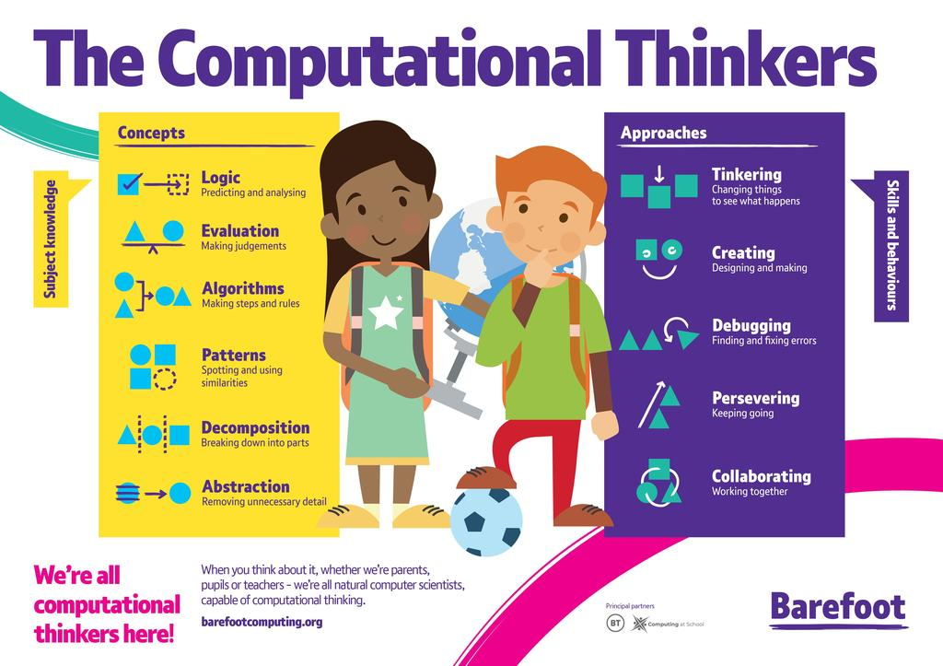
Year 1
Declarative knowledge what I know /acquisition of skill procedural knowledge application of knowledge and skills
Autumn 1 | Spring 1 | Summer 1
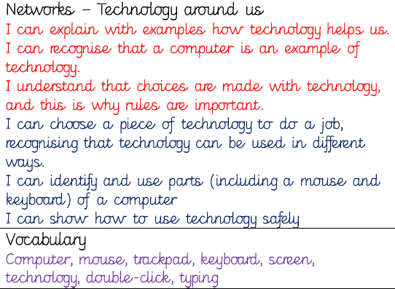 | 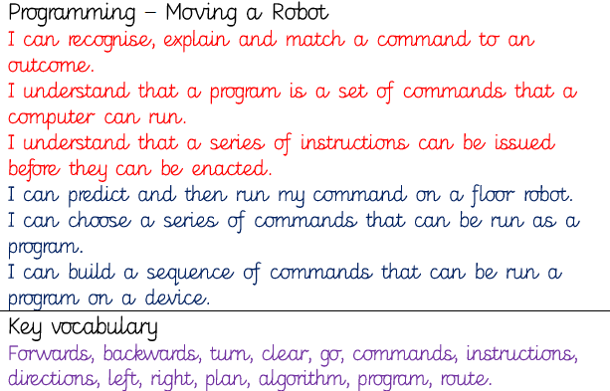 | 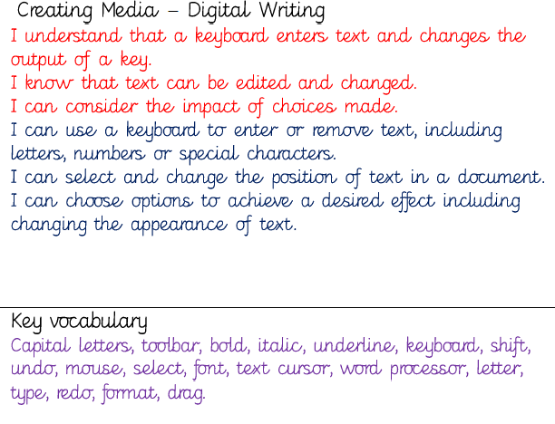
Autumn 2 | Spring 2 | Summer 2
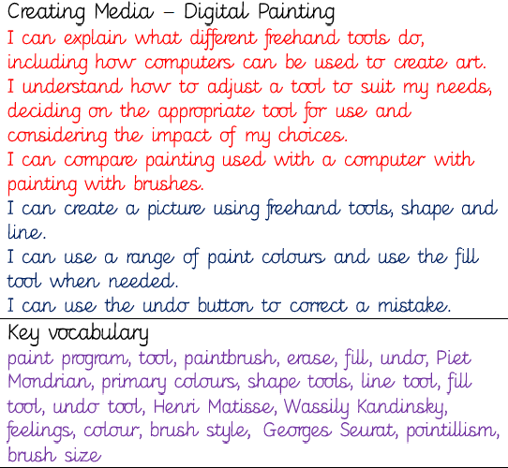 | 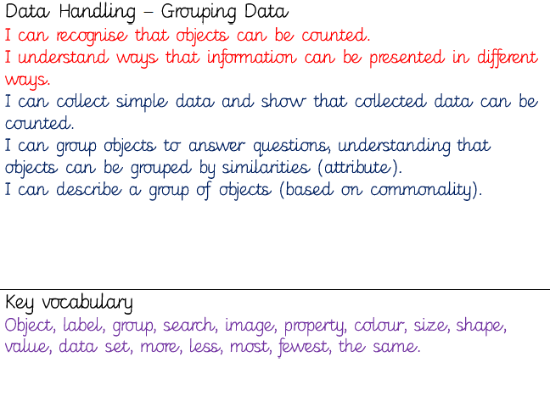 | 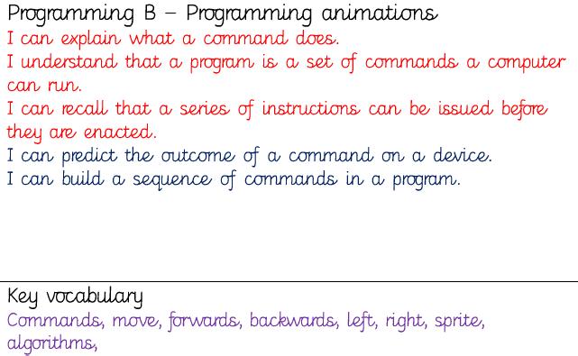

Year 2
Declarative knowledge what I know /acquisition of skill procedural knowledge application of knowledge and skills
Autumn 1 | Spring 1 | Summer 1
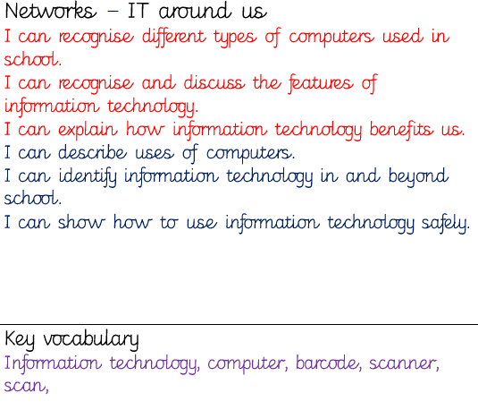 | 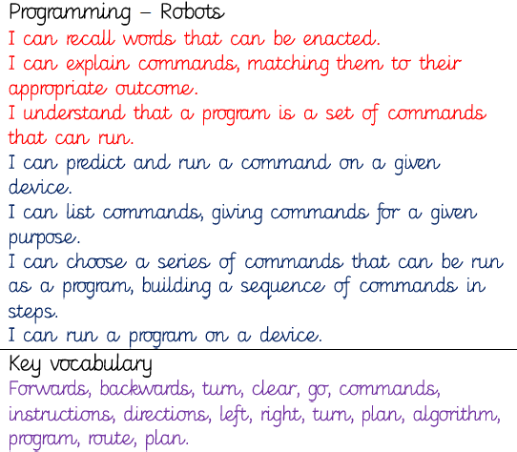 | 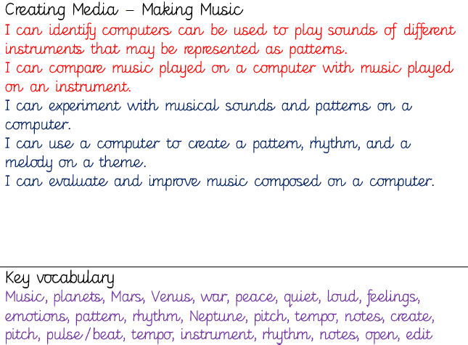
Autumn 2 | Spring 2 | Summer 2
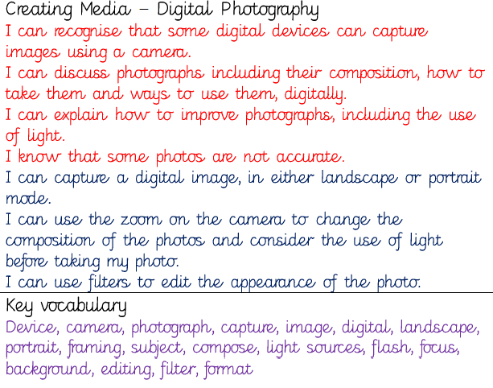 | 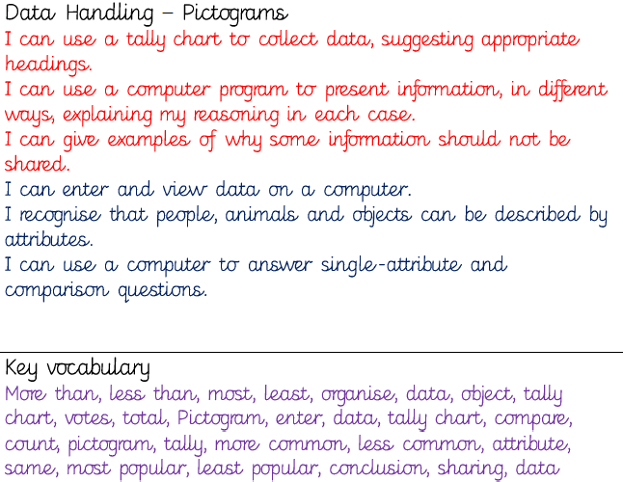 | 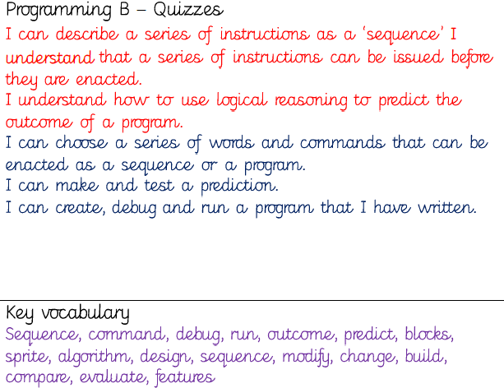

Year 3
Declarative knowledge what I know /acquisition of skill procedural knowledge application of knowledge and skills
Autumn 1 | Spring 1 | Summer 1
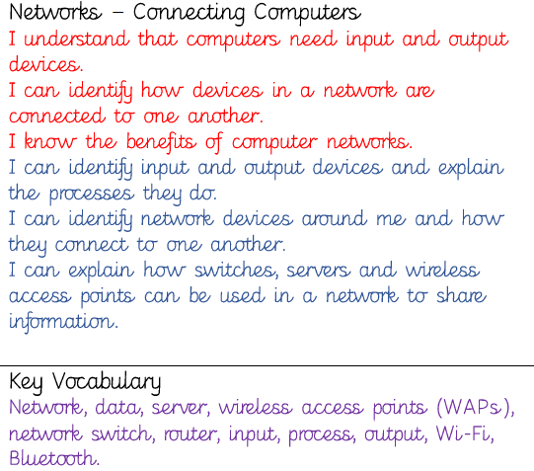 | 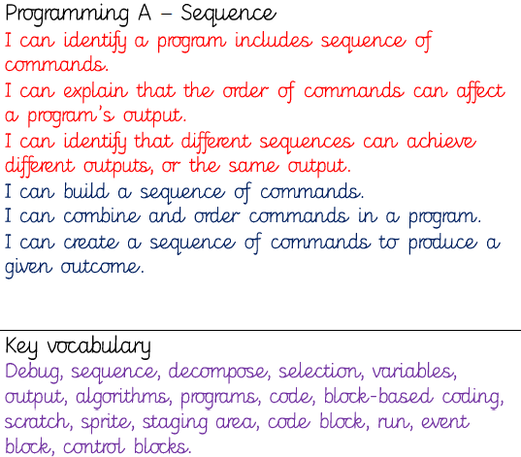 | 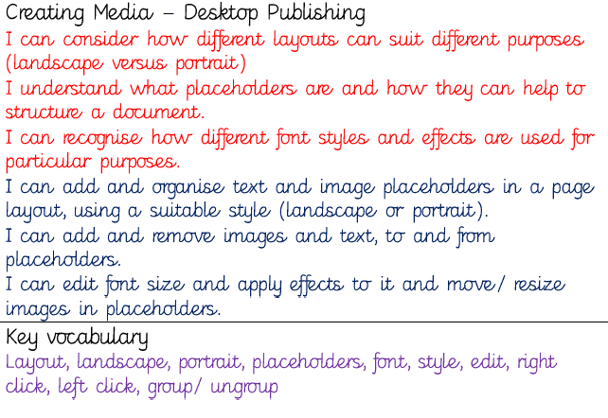
Autumn 2 | Spring 2 | Summer 2
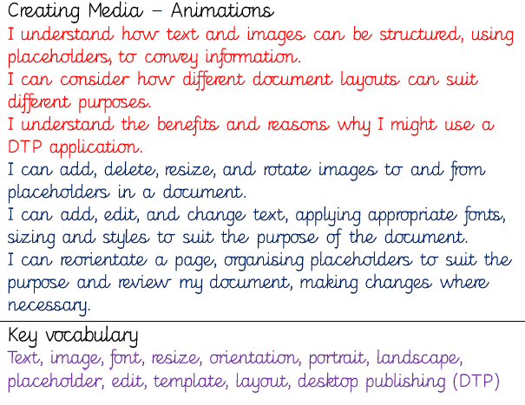 | 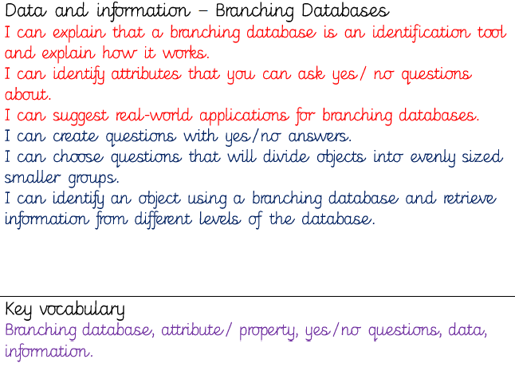 | 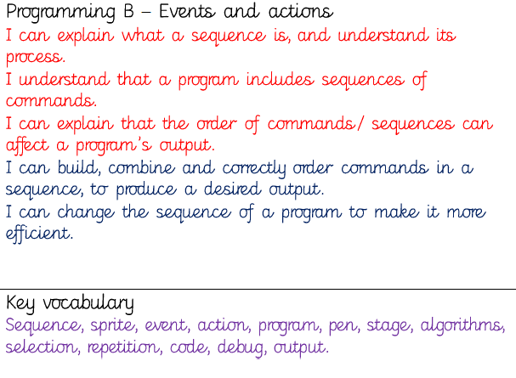

Year 4
Declarative knowledge what I know /acquisition of skill procedural knowledge application of knowledge and skills
Autumn 1 | Spring 1 | Summer 1
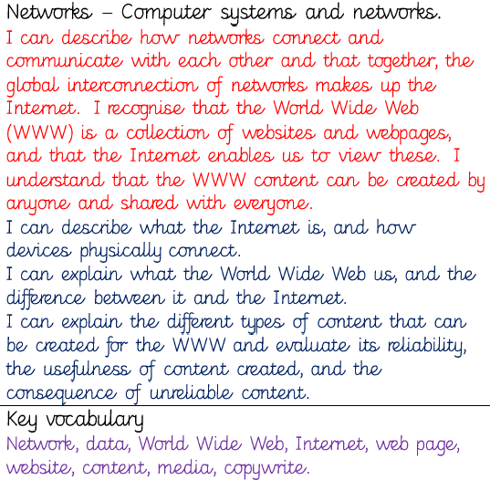 | 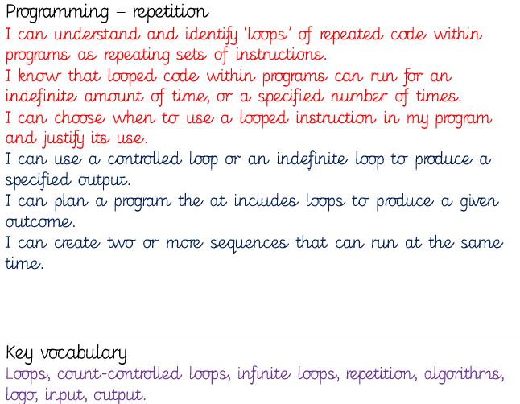 | 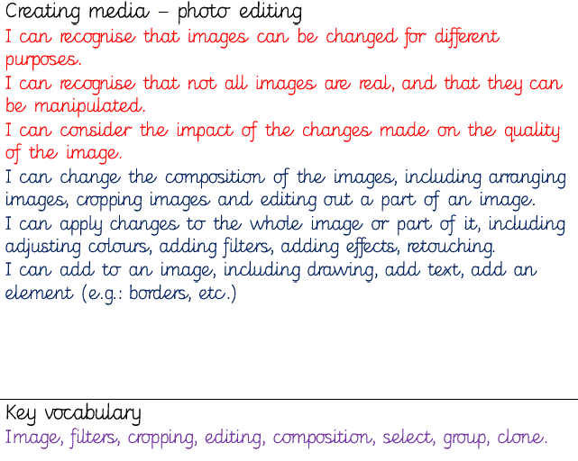
Autumn 2 | Spring 2 | Summer 2
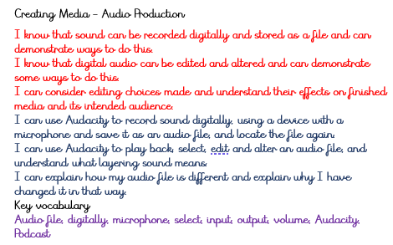 | 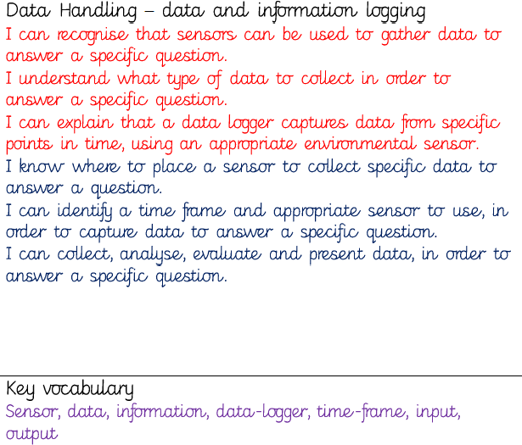 | 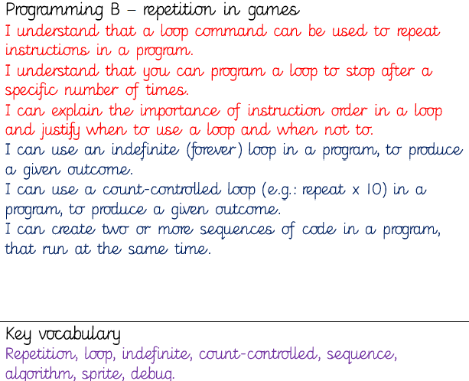

Year 5
Declarative knowledge what I know /acquisition of skill procedural knowledge application of knowledge and skills
Autumn 1 | Spring 1 | Summer 1
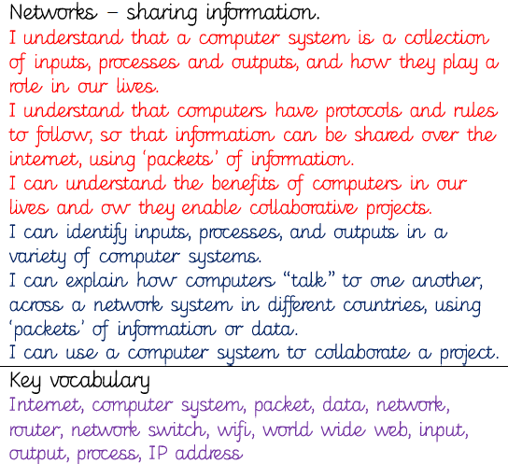 | 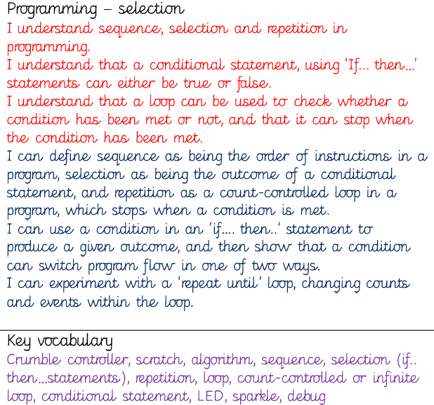 | 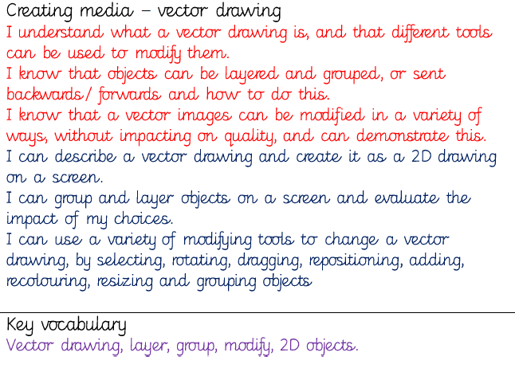
Autumn 2 | Spring 2 | Summer 2
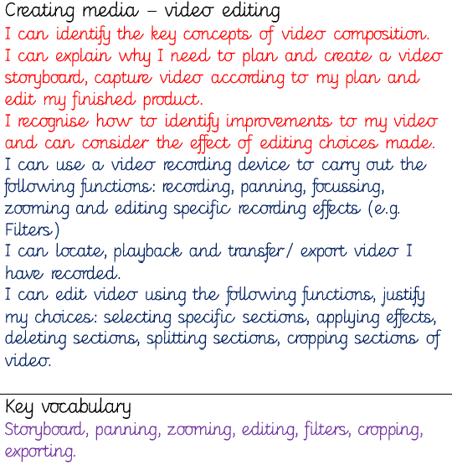 | 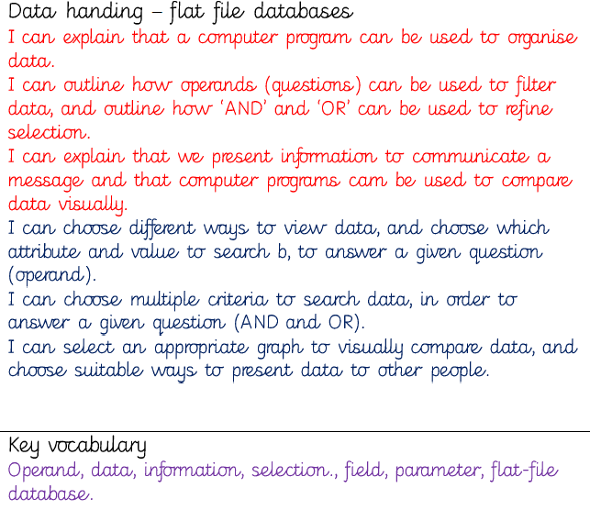 | 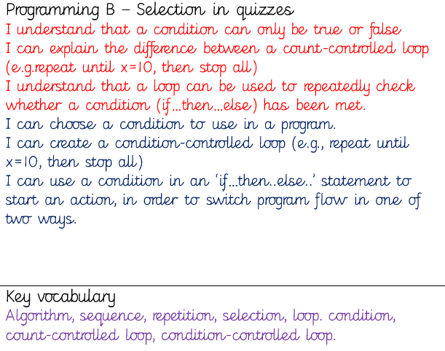

Year 6
Declarative knowledge what I know /acquisition of skill procedural knowledge application of knowledge and skills
Autumn 1 | Spring 1 | Summer 1
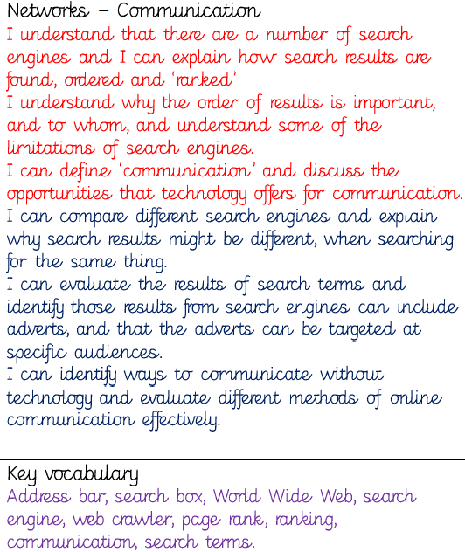 | 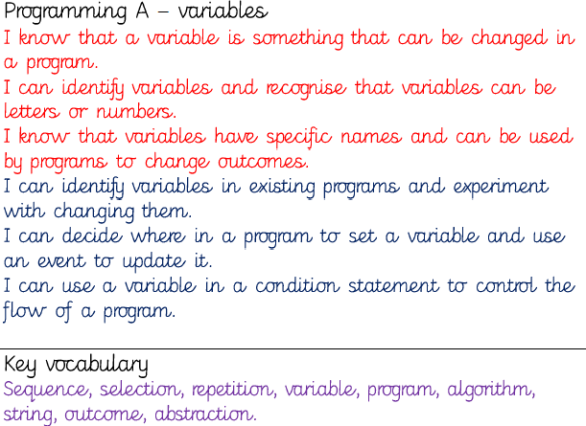 | 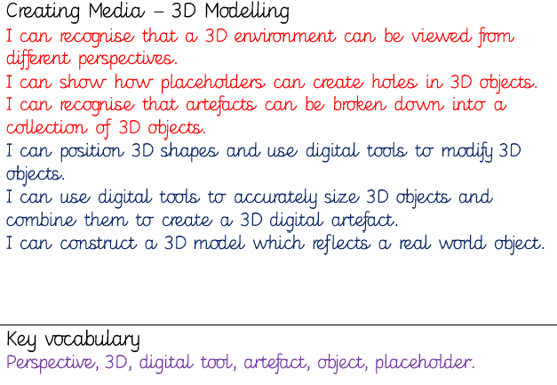
Autumn 2 | Spring 2 | Summer 2
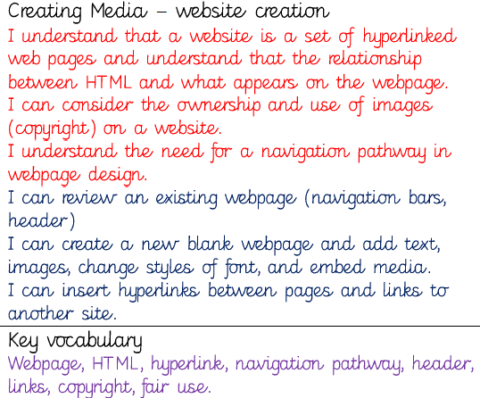 | 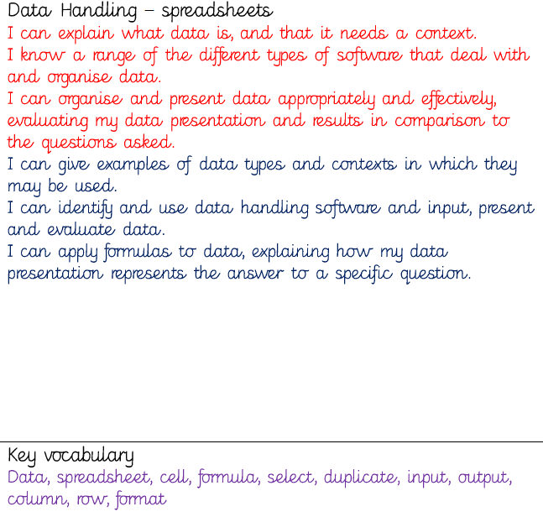 | 