KS2 SUBTRACTION – Year 3 and Year 4

KS1  Prior learning  What should children already know about subtraction? | KS1  Pupils should practise subtraction to 20 and within to become increasingly fluent. They should use the facts they know to derive others, e.g. using 10 - 7 = 3 and 7 = 10 - 3 to calculate 100 - 70 = 30 and 70 = 100 - 30.  Know the effect of zero.  As well as number lines, 100 squares could be used to model calculations such as 74 – 11, 77 – 9 or 36 – 14, where partitioning or adjusting are used.  Pupils should learn to check their calculations, including by adding to check.  They should continue to see subtraction as both take away and finding the difference and should find a small difference by counting up.  They should use Dienes to model partitioning into tens and ones and learn to partition numbers in different ways e.g. 23 = 20 + 3 = 10 + 13.
Year | Year 3 | Year 4
Layers of vocabulary  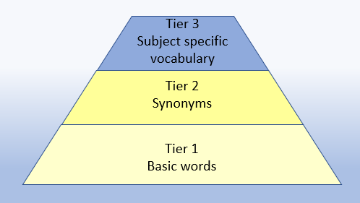  Appendix 1a  Beck’s Tiers of Vocabulary  Appendix 1b: Vocabulary book | Basic to subject specific (Beck’s Tiers):  subtract, subtraction, take (away), minus, leave, one less, two less… ten less… one hundred less…difference between, half, halve = equals, sign, is the same as tens boundary, hundreds boundary, exchange, carried digits, How many are left/left over? How many fewer is…than…? How much less is…?  Instructional vocabulary:  explain your method, explain how you got your answer, give an example of…show how you…show your working  NFER – language of tests and questions  estimate, write….in order, complete, circle, estimate, tick, draw, draw two, draw the arrow, show your working, use the, complete, shade, write in, true or false, tick two, circle all, , use a ruler, write a possible, What is…? What is next? How many…? What number…? Which of these? What numbers could be…? How many are left? | Basic to subject specific (Beck’s Tiers):  subtract, subtraction, take (away), minus, decrease, leave, difference between, half, halve, equals, sign, is the same as tens boundary, hundreds boundary, inverse, exchange, carried digits, How many are left/left over? How many more/fewer is…than…? How much more/less is…?  Instructional vocabulary:  calculate, work out, solve, investigate, question, answer check  NFER – language of tests and questions  write, order, complete, draw three, write….in the boxes, show your working, use the method, write the missing, shade, write in order, tick, write your answer as…, write the letter (can be used more than once), describe, write one word, write your answer in, match, to make…you need, draw four, on which, calculate, write these numbers, use the coordinates to draw, estimate, in each box, write these values, circle the best, complete the table, round each number, draw one line, circle all, tick three, plot, check, How many…? What is…? How much? What number…? Who takes…
KS2 SUBTRACTION – Year 3 and Year 4

Year | Year 3 | Year 4

Known facts | Derive and use addition and subtraction facts to 100, e.g. 33+ 67 =100. | Derive and use addition and subtraction facts (for multiples of 10) to 1000, e.g. 330+ 670=1000.

Essential knowledge | Subtract single digit bridging through boundaries | Subtract multiples of 10,100 | Fluency of 2 digit - 2 digit | Subtract multiples of 10, 100 and 1000
Essential knowledge | Partition second number to subtract | Pairs of 100 (complements of 100) | Partition second number to subtract | Decimal subtraction from 10 or 1
Essential knowledge | Difference between | Subtract near multiples of 10 and 100 by rounding and adjusting | Difference between | Subtract near multiples by rounding and adjusting
Essential knowledge | Partition and recombine

NC 2014 | Add and subtract numbers with up to 3 digits, using formal written methods of columnar addition and subtraction. Least significant digit is always dealt with first to establish if the exchange is needed. | Add and subtract numbers with up to 4 digits using the formal written method of columnar addition and subtraction where appropriate. Solve addition and subtraction two-step problems in contexts, deciding which operations and methods to use and why.

KS2 SUBTRACTION – Year 3 and Year 4

 | concrete, pictorial, abstract
Year | Year 3 |  |  | Year 4
Developing Conceptual/  Procedural Understanding  Columns to be headed  HTU | Subtract ones  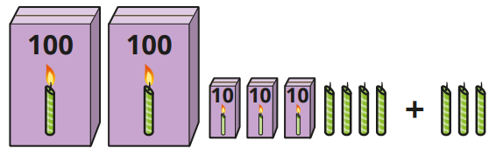  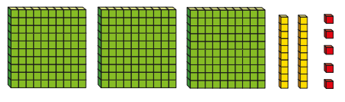  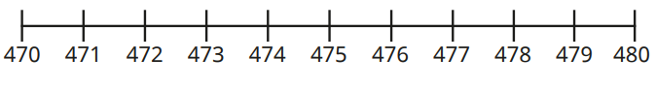  Subtract tens  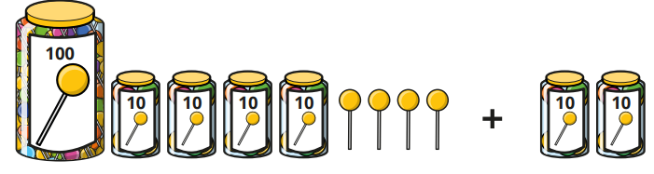  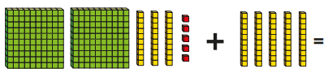  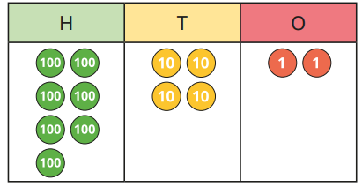  Subtract hundreds  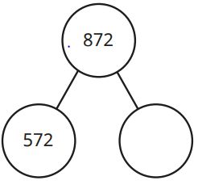  Subtract mentally pairs of multiples of 100 using known facts  600 – 200 = 400 because 6 – 2 = 4  Remodelling strategy (keeping the difference the same)  502 – 198  504 – 200 = 304  Re-arranging  Use of apparatus to understand rearrangements, e.g. 55 as 40 and 15(not as part of calculations).  Place value materials to represent calculations  Diennes and then place value counters. | Subtract 1s across a ten  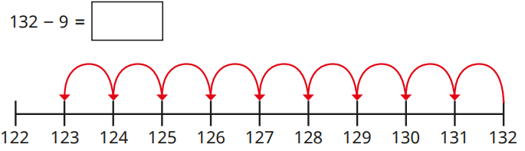  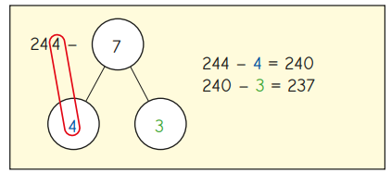  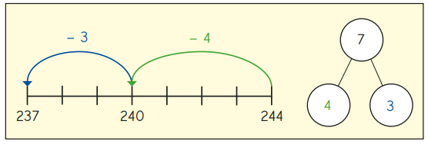  Subtract 10s across a hundred  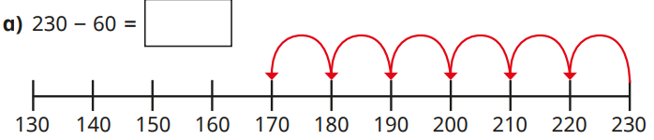  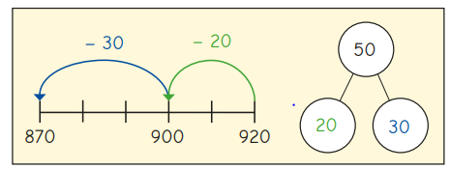  Start with least significant digit -decomposition  8 1 = 8 0 1  - 5 7 5 0 7  ______  8 1 = 7 0 1 1  - 5 7 5 0 7  2 4 2 0 4  “1 subtract 7 is tricky so I will rearrange 81 into 70 and 11. 11 subtract 7 equals 4 and 70 subtract 50 equals 20. 20 and 4 make 24.”  81 – 57 =  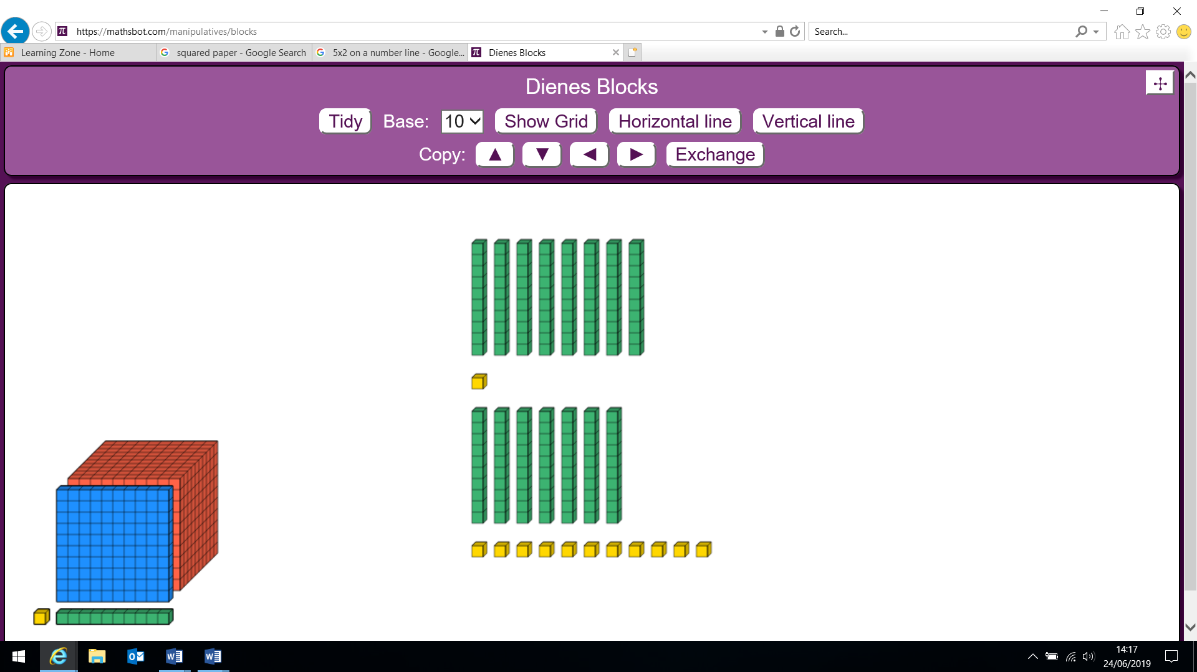  81 becomes 70 and 11  754 – 86 =  7 0 0 5 0 4  6 0 0 1 4 0 1 4  - 8 0 6  6 00 6 0 8  “It’s tricky to take 6 from 4 and 80 from 50. I need to rearrange the number. I will exchange one ten from 50 which leaves 40 and makes 14 in the units. | Columnar subtraction  Subtract two numbers (no exchange)  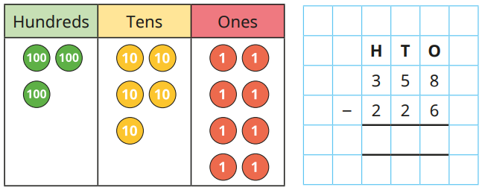  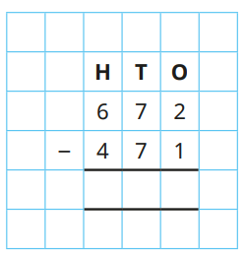  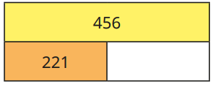  Subtract two numbers (across a ten)  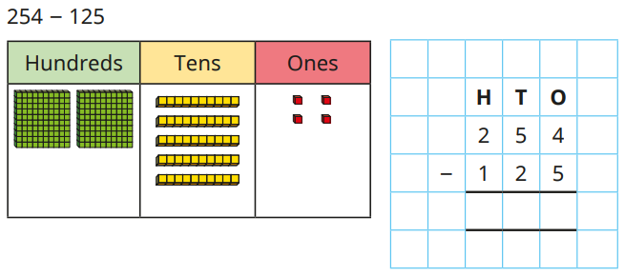  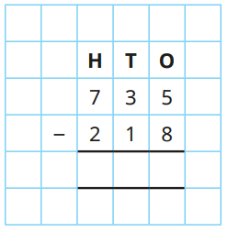  Subtract two numbers (across a hundred)  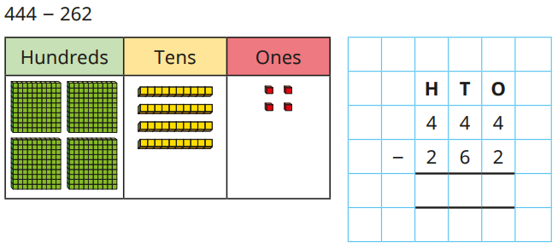  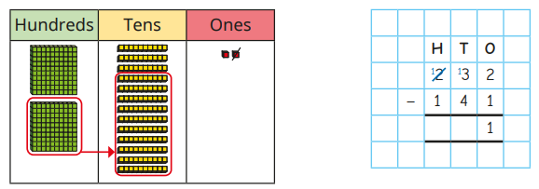  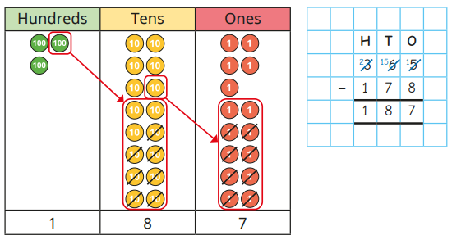  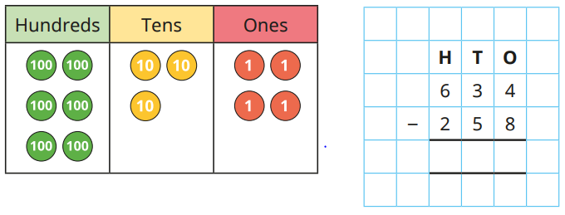  754 – 286 =  40 to subtract 80 is tricky. I will exchange one hundred from 700 and make 140. 14 subtract 6 equals 8. 140 subtract 80 equals 60 and 600 subtract 0 equals 600.”  Emphasis on language of place value, i.e. 14 units subtract 6 units, 14 tens subtract 8 tens, and 6 hundreds subtract 2 hundreds.  Representing problems  There are 386 pupils at Oak Primary. If 79 pupils have sandwiches, how many have dinners?  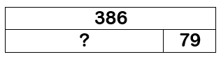  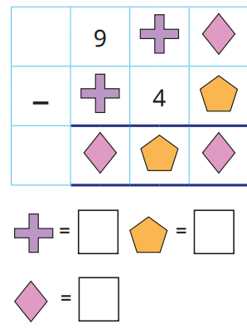 | Subtract mentally pairs of multiples of 1000 using known facts  6000 – 2000= 4000 because  6 – 2 = 4  Remodelling strategy (keeping the difference the same)  3548 - 1998  3550 – 2000 = 1550  Find the difference strategy  13 .6 – 2.8 =  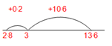  13.6 – 2.8 = 10.8  Place value materials to represent calculations  Subtract 1s, 10s, 100s and 1000s  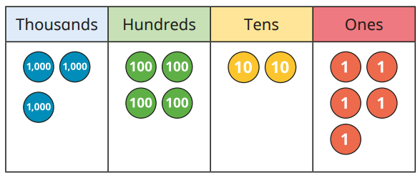  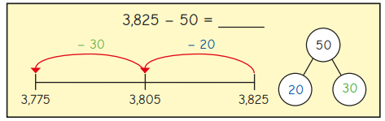 | Columnar subtraction  Subtract two 4-digit numbers (no exchange)  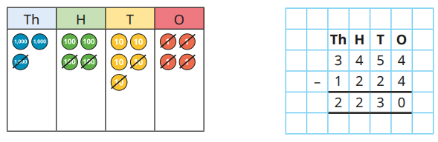  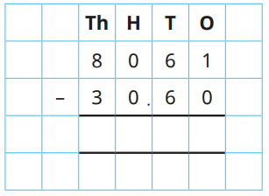  Subtract two 4-digit numbers (one exchange)  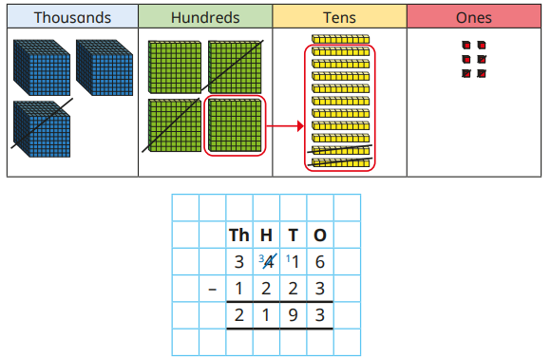  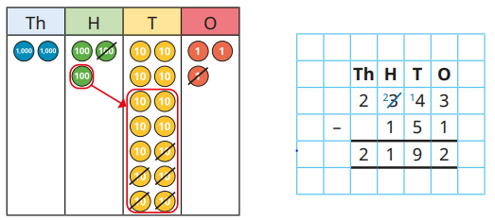  Subtract two 4-digit numbers (more than one exchange)  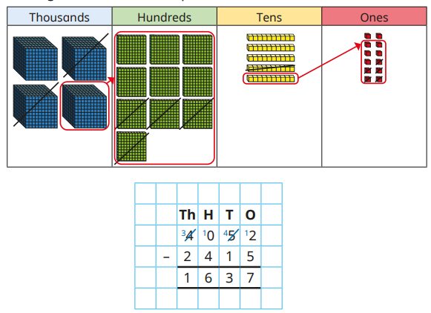  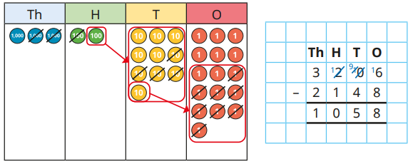  2344 -187  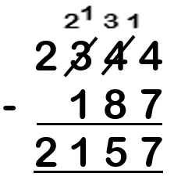  6467 – 2684  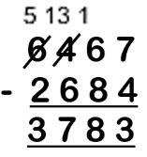  Columnar subtraction (decimals) in contexts such as money and measurement  32.34 – 14.18  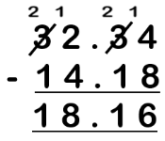 | Efficientcy of strategy choice  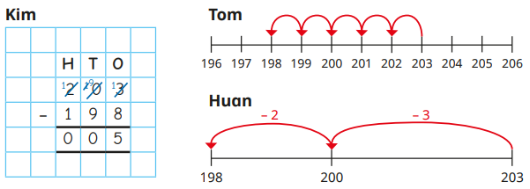  Representing problems  Check the answer to the following calculations using the inverse. Show all your working.  2456- 734 = 1822

KS2 SUBTRACTION – Year 5 and Year 6

Year | Year 5 | Year 6
Layers of vocabulary  Appendix 1a  Beck’s Tiers of Vocabulary  Appendix 1b: Vocabulary book | Basic to subject specific (Beck’s Tiers):  subtract, subtraction, take (away), minus, leave, ten less… one hundred less…difference between, half, halve, = equals, sign, is the same as tens boundary, hundreds boundary, inverse, units boundary, tenths boundary, exchange, carried digits, How many are left/left over? How many fewer is…than…? How much less is…?  Instructional vocabulary:  put, place, arrange, rearrange, change, change over, adjusting, adjust split, separate  NFER– language of tests and questions  complete the sequence, circle the same as, draw four lines, circle the, circle the number that is not, circle two, circle two, write yes or no to a statement, circle all, write the, write the missing, circle the incorrect, show your method, show your working, circle three, by how much, calculate, estimate, shade, write the missing, use the diagram, complete the table, circle the number that is both, write a, b, c, d, label, true or false, order, draw a line, write the missing digits, circle true and false, tick two, What number is…? Which is the closest? Which one of these must also…? Who gets the most? What is the total number? | Basic to subject specific (Beck’s Tiers):  subtract, subtraction, take (away), minus, decrease, leave, difference between, half, halve, = equals, sign, is the same as tens boundary, hundreds boundary, units boundary, tenths boundary, inverse, How many are left/left over? How many more/fewer is…than…? How much more/less is…?  Instructional vocabulary:  put, place, arrange, rearrange, change, change over, adjusting, adjust, split, separate, carry on, continue, repeat, predict, describe the pattern, describe the rule, find, find all, find different investigate, What comes next?  NFER– language of tests and questions  write three, complete, draw the, explain why, write each number, what is, show your method, tick the, calculate, increase by, complete the tables, circle all, calculate, What was the…? What is the difference? Which expression? How much? What is the difference? What are…? What could…? What number is? Which of these…?

KS2 SUBTRACTION – Year 5 and Year 6

Year | Year 5 | Year 6

Known facts | Derive and use addition and subtraction facts to 10 and 1, e.g. 3.3 + 6.7 = 10 leads to 10 – 3.3 = 6.7 and 0.33 + 0.67 = 1 so 1 – 0.67 = 0.33. BIDMAS. | All the KS2 required facts. BIDMAS.

Essential knowledge | Fluency of 2 digit - 2 digit including with decimals | Subtract multiples of 10, 100, 1000 and tenths | Fluency of 2 digit - 2 digit including with decimals | Subtract multiples of 10, 100, 1000, tenths and hundredths
Essential knowledge | Partition second number to subtract | Use number facts, bridging and place value | Partition second number to subtract | Use number facts, bridging and place value
Essential knowledge | Adjust numbers to subtract | Difference between | Adjust numbers to subtract | Difference between
Essential knowledge | Negative numbers, counting forwards and backwards through zero |  | Negative numbers, calculate intervals across zero

NC 2014 | Add and subtract whole numbers with more than 4 digits, including using formal written methods (columnar addition and subtraction).  Solve addition and subtraction multi-step problems in contexts, deciding which operations and methods to use and why. | Solve problems involving addition, subtraction, multiplication and division.

KS2 SUBTRACTION – Year 5 and Year 6

 |  | concrete, pictorial, abstract
Year |  | Year 5 |  | Year 6
Developing Conceptual/  Procedural Understanding | Columnar subtraction  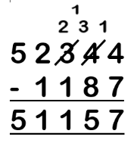  Include calculations with decimal point and missing digits.  324.9 - 7.25  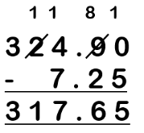  Use rounding and estimating to check answers. |  | Representing problems  Kangchenjunga is the third highest mountain in the world at 28,169 feet above sea level. Lhotse is the fourth highest at 27,960 feet above sea level. Find the difference in heights mentally.  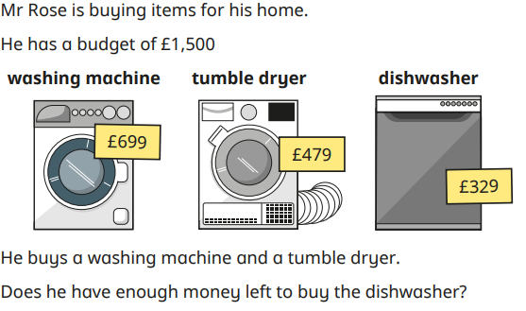  Lead onto multi-step subtraction problems. | Columnar subtraction  Include calculations with decimal point and more missing digits.  128.7 - 3.014  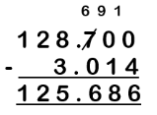  Find the difference strategy  122456 – 11999  +1 to each side of the equation  122457 - 12000 | Representing problems  Katie was given the calculation below 47326 – 1900 = She said “I will just take off 2000 then subtract another 100 so my answer is 45126.” Is she correct? Would you use her method? Explain your answer.

