Computing Role Models and Pioneers

Reception | Year 1 | Year 2 | Year 3 | Year 4 | Year 5 | Year 6
Douglas Englebart 1925 - 2013 Englebart is credited with inventing the first computer mouse, a wooden box with two metal wheels in it. He and his team also created bit-mapped screens, hypertext and some precursors to the graphical user interface (GUI). | Grace Hopper 1906 - 1992 Hopper was a computer scientist and US Navy Admiral. She was the first to use the term “debugging” for fixing computer problems. Hopper developed the first working compiler and developed COBOL, a programming language still used today | Ada Lovelace 1815 - 1852 Lovelace is credited with the title “the first programmer”. She worked with Charles Babbage’s Analytical Engine to develop what is recognised as the first algorithm intended to be processed by a machine. She was the daughter of poet Lord Byron. | Xia Peisu 1923 – 2014  She is regarded as the ‘Mother of Computer Science in China’. She was the leading developer of Model 107, the first home computer which was designed in China. | Tim Berners-Lee 1955 - Present Berners-Lee is an engineer and computer scientist, best known as the inventor of the World Wide Web. He made a proposal for an information management system in March 1989 and implemented the first successful communication between a HTTP client and server via the internet in mid-November the same year. | Annie Easley 1933 - 2011  Easley worked for NASA. She was a leading member of the team which developed software for the Centaur high-energy upper rocket stage. Her work on this project helped lay the foundations for future space shuttle launches and the launches of communication, military and weather satellites | Hessa Al Jaber 1961 – Present  Al Jaber has revolutionised Qatars ICT infrastructure and telecommunications. This included laying plans for the country’s national broadband network. She has also led the way to protect children who use the internet, founding ‘Safe Space’ an Internet Safety website . She also campaigned for more Arabic content on the internet, increasing digital literacy in Arabic speaking countries.
American | American | British | Chinese | British | American | Qatari
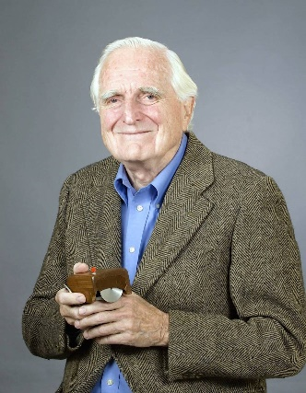 | 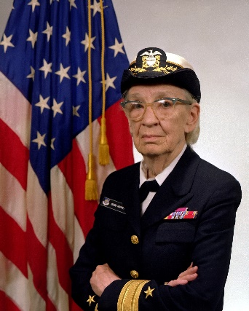 | 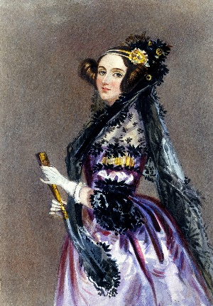 | 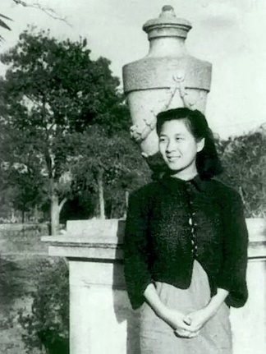 |  | 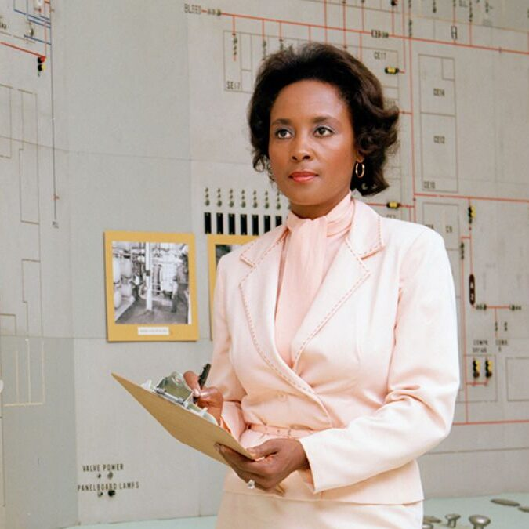 | 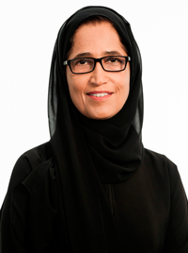
Suporting Links | Suporting Links | Suporting Links | Suporting Links | Suporting Links | Suporting Links | Suporting Links
Douglas C. Engelbart - 2000 National Medal of Technology (youtube.com)  What device did Douglas Engelbart invent? | HowStuffWorks | Who is Grace Hopper? (youtube.com)  March 6, 1983: Grace Hopper—She taught computers to talk (youtube.com) | The Brilliant Mind of Ada Lovelace: Victorian Countess & Computer Programmer (youtube.com)  ADA LOVELACE | Draw My Life | International Women’s Day (youtube.com) | Xia Peisu (1923-2014) | The University of Edinburgh  Xia Peisu Facts for Kids (kiddle.co) | Tim Berners-Lee Facts for Kids (kiddle.co)  Tim-Berners Lee and the Invention of the Internet for Kids | Bedtime History (youtube.com) | Annie Easley Facts for Kids (kiddle.co)  Learn about Annie Easley (youtube.com) | Hessa Al Jaber - Wikipedia  Dr. Hessa Al-Jaber Discusses Digital Communications Literacy - Digital Media Literacy Forum (youtube.com)

