History Progression of Disciplinary Knowledge
Year group | Reception | Year 1 | Year 2 | Year 3 | Year 4 | Year 5 | Year 6
Scope | Understanding the World Past and Present (ELG)  Birth to 5 & Development matters People & Communities | Significant events, people, places in own locality.  Events beyond living memory.  Changes within living memory  The lives of significant individuals in the past who have contributed to national and international achievements. |  | A local history study  Changes in Britain from the Stone Age to the Iron Age. | The Roman Empire and its impact on Britain  The achievements of the earliest civilizations and a depth study of one. | A non-European society that provides a contrast with British History.  Ancient Greece – a study of Greek life and achievements and their influence on the western world. | A study of an aspect or theme in British history that extends pupils’ chronological knowledge beyond 1066.  Britain’s settlement by Anglo-Saxons and Scots.  The Viking and Anglo-Saxon struggle for the Kingdom of England to the time of Edward the Confessor.
Cause & Consequence | To talk about the lives of the people around them and their roles in society. | To recognise why a historical event happened.  To identify how a historical event can change people’s lives. | To understand that there are reasons why people in the past acted as they did.  To identify causes and consequences to events from the past. | To find out about the cause of an event.  To identify key consequences over a period of time and be able to give reasons for those changes. | To explain how people and events in the past have influenced life today.  To describe connections and contrasts between aspects of history, people, events and artefacts studied. | To identify and note connections, contrasts and trends over time in the everyday lives of people.  To use appropriate historical terms such as culture, religious, social, economic and political when describing the past. | To examine causes and results of great events and the impact these had on people.  To describe the key features of the past, including attitudes, beliefs and the everyday lives of men, women and children.
Teaching points | Cause and consequence is a relationship in history between an event, a condition, or a decision (the cause) and the events or results that follow it (the consequences).  Understanding cause and consequence is a key aspect of historical analysis and helps historians to understand how and why things happened in the past.  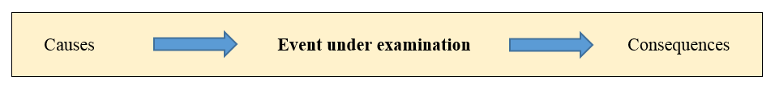
Example Question Stems | Why did they act as they did? Why did this event occur? What led to this event taking place? What were the consequences of these actions?  Why did X happen? What led to X? What was the impact of …? How did … change because of this? What might have happened if…? Why do think X happened? How could X have been prevented? What happened afterwards? Why did that happen following X?  Why did X happen? What led to X? What was the impact of …? How did … change because of this? What might have happened if…? Why do think X happened? How could X have been prevented? What happened afterwards? Why did that happen following X?
Change and continuity | To compare and contrast characters from stories, including figures from the past. | To recognise some similarities and differences between the past and the present. | To identify similarities and differences between ways of life in different periods. | To find out about the everyday lives of people compared with our life today. | To explain how people and events in the past have influenced life today. | To describe connections and contrasts between aspects of history, people, events and artefacts studied. | To use appropriate historical terms such as culture, religious, social, economic and political when describing the past.
Teaching points | Change and Continuity: change and continuity form the foundation of the study of history, as historians seek to understand both the ways in which societies and cultures have evolved over time, as well as the ways in which certain elements have remained constant. By examining both change and continuity, historians can gain a more complete understanding of the complexities of the human experience.
Example Question Stems | What happened after…? Can you name the …? What happened before…? Who was it that….? When…?  What differences/similarities exist between…? What do you think happened next? Provide an example to support/ exemplify your point. How did this change…? How quickly/ slowly did this change? How big/small was the change? How can you prove that?  What kind of historical development are you focusing on (e.g., religious, political, economic, cultural, etc.)? What was the situation like before this occurred? What was clearly different after this occurred? What were the direct causes of the changes? What were the reasons that some things remained the same?
Similarity and difference | To know some similarities and differences between things in the past and now, drawing on their experiences and what has been read in class. | To identify similarities and differences between societies e.g. within 17th Century London (Royalty and  Peasantry). | To recognise some similarities and differences between individuals e.g. Charles Darwin and Sir David Attenborough | To find similarities and differences between an aspect of society e.g. nomadic to settlements | To find similarities and differences between places e.g. Britain and the rest of the Roman Empire (Culture,  religion, military). | To describe connections and contrasts between aspects of history, people, events and artefacts e.g. within Ancient Greece | To examine and explain diverse experiences and ideas, beliefs, attitudes of men, women, children e.g. within the period of the First World War.
Teaching points | Similarity and difference is based upon an understanding of the complexity of people’s lives, differing perspectives and relationships between different groups. Asking how similar or different allows pupils to draw comparisons across people, their perspectives, motivations and actions as well as across time and space, helping children to develop a greater understanding of modern global society.
Example Question Stems | What are the features of…? How would X describe….? What happened to…? How can you prove….? What evidence shows….?
Historical significance | To understand the past through settings, characters and events encountered in books read in class and storytelling. | To recognise why certain individuals e.g. Thomas Telford are significant in history (achievements and impact) | To identify and describe why certain people/events are significant in the wider context of history e.g. Wright Brothers and the first aeroplane flight. | To find out and describe why advancements in the Stone, Bronze and Iron Ages were significant to the development of Britain.  To identify why our interpretations of Stone Age to Iron Age is difficult due to limited primary sources or written evidence. | To describe and discuss the achievements of the Ancient Egyptians and their significance to human development. | To explain advancements in technology e.g. in the Mayan civilisation.  To evaluate the achievements of the Ancient Greeks and their significance to human development. | To evaluate the achievements of the First World War as a turning point in British history in the context of then and now e.g. development of tank warfare, (new technology), medical advancements (blood bank,)
Teaching point | Historical significance: Children must understand that history is not black and white but rather shades of grey. There are no right answers but rather different versions of the truth. This concept recognizes both the subjective nature of historical evidence and the validity of multiple narrators. Children need to understand that primary evidence including oral history is not necessarily objective but depends on why the account was created. They also need to be aware that the different stories about the same event can both be true depending on the point of view of the narrator. This concept considers the reliability of evidence looking at fact, bias or point of view.
Example Question Stems | What effects did the X have on …? Was this a more significant event for one or the other? Was it equally significant for the same or different reasons? How significant was the X? did the X change anything significant for/in …?
Sources and evidence | To comment on images of familiar situations in the past. | To look at simple artefacts and pictures to ask questions about the past. | To look at a source to find answers to questions about the past.  To choose and select evidence (from a selection provided) and say how it can be used to find out about the past. | To gather more detail from sources such as maps to build up a clearer picture of the past.  To suggest sources of evidence to help answer questions to present findings. | To devise my own questions to find answers about the past.  To begin to undertake my own research.  To compare different accounts of an event and explain why they may differ. | To recognise when I am using primary and secondary sources of information to investigate questions about the past.  To select relevant sections of information to address historically valid questions and construct informed responses. | To use a wide range of different evidence to collect evidence about the past, such as pictures, documents, printed sources, posters, online material, pictures, photographs, artefacts, historical statues, figures, sculptures and historical sites.  To investigate my own lines of enquiry by posing historically valid questions to answer.
Teaching points | Sources and Evidence: Sources are traces of the human past. Without historical sources we have no history, nothing to build a picture of the past from, nothing to help us try to answer our questions about what came before. Of course, we can never have a complete picture because we do not have access to everything that was ever made, written or more importantly, thought. Historians use sources and evidence to construct knowledge of the past.  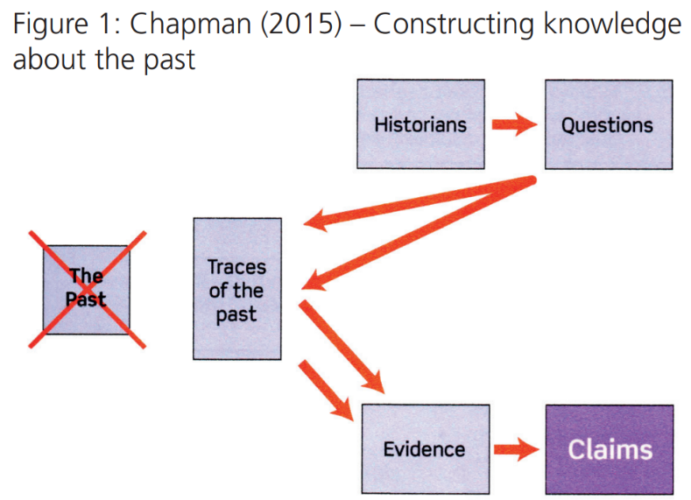
Example Question Stems | What does X tell us about life in X? Wat does X tell us about life in X? What does it look like? What does it feel like? What is the condition? What materials is it made of? Is it mass-produced or hand-made? Is it complete? Is it decorated? How does it work? Who might have used it? Where might it have been used? Does it require a skill to be used? What impact did this object have on people’s lives? Would this have been widely used? What is the significance of this object? What does the source tell us? What do we now know, that we didn’t know before? What can we infer? When was the source produced? What further questions do we have now? What was the intended purpose? Do we know why the source was produced? Do we know who produced this source and why?  In addition to…, the evidence supports …., The evidence would suggest otherwise because…, As a result of the evidence… To summarise the evidence…, Overall, the evidence suggests...
Historical interpretations |  | To use pictures, photographs or artefacts to find out about the past.  To use stories or accounts to find out about the past. | To explain that there are different types of sources that can be used to help represent the past. | To look at two versions of the same event or story in history and identify differences. | To investigate different accounts of historical events and be able to explain some of the reasons why the accounts may be different. | To start to understand the difference between primary and secondary evidence and the impact of this on reliability.  To evaluate the usefulness of different sources. | To know that people in the past represent events or ideas in a way that may be to persuade others.  To show an awareness of the concept of propaganda and understand how and why it is used (World War 1)
Teaching points | Historical Interpretations: The study of historical interpretations relates to an understanding of how and why different accounts of the past are constructed.
Example Question Stems | How might we think differently today? How might someone at that time think about…? How do we know if that is a fact or an opinion? How are the viewpoints different?

