History Progression of Substantive Knowledge
Year group | Reception | Year 1 | Year 2 | Year 3 | Year 4 | Year 5 | Year 6
Key Substantive Concepts | Invasion & Empire  Settlements & Social History  Crime and Punishment  Communication and Invention
Scope | Understanding the World Past and Present (ELG)  Birth to 5 & Development matters People & Communities | Significant events, people, places in own locality.  Events beyond living memory.  Changes within living memory  The lives of significant individuals in the past who have contributed to national and international achievements. |  | A local history study  Changes in Britain from the Stone Age to the Iron Age. | The Roman Empire and its impact on Britain  The achievements of the earliest civilizations and a depth study of one. | A non-European society that provides a contrast with British History.  Ancient Greece – a study of Greek life and achievements and their influence on the western world. | A study of an aspect or theme in British history that extends pupils’ chronological knowledge beyond 1066.  Britain’s settlement by Anglo-Saxons and Scots.  The Viking and Anglo-Saxon struggle for the Kingdom of England to the time of Edward the Confessor.
Key Dates | Living memory  Past & Present | 1777 – Ironbridge  1666 – The Great Fire of London  1853 – St Mary’s Catholic Church Completed | 1983 – First hot air balloon flight.  1903 – Wright Brothers Flight  1961 – First flight into space.  1809 – Charles Darwin Birth  1926 – David Attenborough Birth | 15000 – 3000BC Stone Age  3000BC – 800BC Bronze Age  800BC – 43AD Iron Age  1760AD – 1840AD – Industrial  Revolution | 43AD – 410AD Romans  7500BC – 30AD Egyptians  5000BC – 2330BC – Ancient Sumer  3300BC – 1500BC – Indus Valley  1766BC – 1046BC – Shang Dynasty of Ancient China | 1100BC – 1502AD – Mayans  776BC – 146BC – Ancient Greece | 449AD – 1066AD Anglo Saxons  793AD – 1066 Vikings  1914 – 1918 – World War 1
Chronology  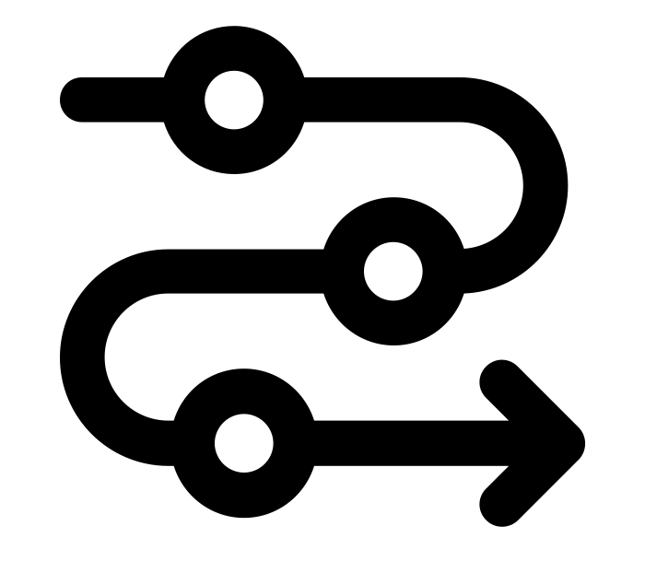 | To begin to make sense of their own life-story and family’s history.  To talk about the lives of the people around them and their roles in society. | To sequence pictures from different periods.  To describe memories and changes that have happened in their own lives.  To use common words and phrases relating to the passing of time e.g. now, then, past, old, new. | To order dates from earliest to latest on simple timelines.  To sequence events on a timeline using phrases relating to the passing of time e.g. now, then, yesterday, days, weeks, years, nowadays, past, old, new. | To use an increasing range of common words, dates and phrases relating to the passing of time e.g. BC and AD.  To know the Stone Age is divided into three periods  -Palaeolithic 30,000 BC – 10,000 BC  -Mesolithic 10,000BC – 8,000BC  -Neolithic 8000BC – 3000BC | To place and describe some historical periods and eras on a timeline.  To use historic vocabulary to discuss and describe dates, time, periods, eras, chronology and changes. | To understand the concepts of continuity and change over time, representing them, along with evidence, on a timeline.  To use dates (BC and AD) and terms accurately in describing events. | To sequence local, national and international events as well as historical periods.  To identify periods of rapid change in history and contrast them with times of relatively little change.  To describe the main changes in a period of history (using terms such as: social, religious, political, technological and cultural).
Vocabulary | family, grandma, grandpa, cousin, mum, dad, brother, sister, past, now, past, present, now a long time ago | Now, then, past, present, old, new, a long time ago, years ago | Now, then, yesterday, days, weeks, years, nowadays, past, old, new. dates | BC, AD, dates, period, | Period, era, chronology, dates | Period, era, chronology, changes, dates | Local, national, international, BC, AD, dates, continuity, evidence, sequence, events, periods, accurate, social, religious, political, technological, cultural, change, contrast
Invasion & Empire  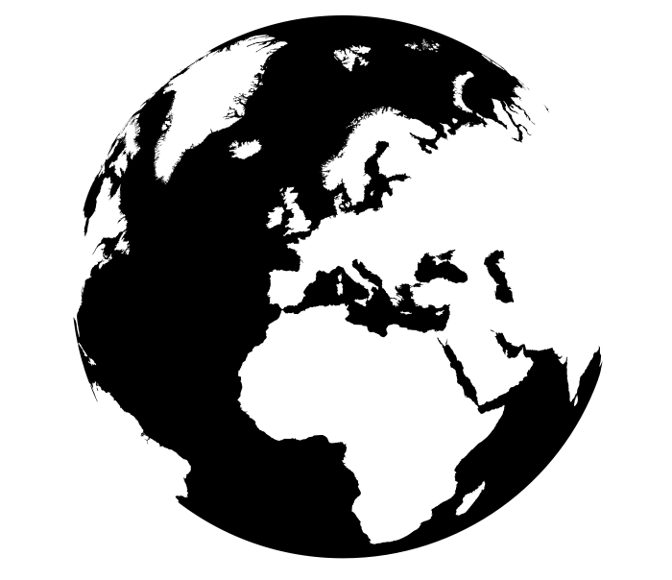 | To know the concepts king, queen and kingdom. | To know that London in 1666 was the capital of the British Empire. | To know that Charles Darwin was an explorer as well as being a naturalist. | To know that the Iron Age ended in 43AD after the final Roman invasion of Britain.  To know that the Victorian period saw the British Empire grow to become the first global industrial power.  Know that the British Empire has a legacy today. | To know that Boudicca and Celtic warriors revolted against the Roman invaders.  To know that the Britain was once part of the Roman Empire.  To know that Claudius successfully invaded Britain in 43AD.  To know that Julius Caesar led two expeditions to Britain in 55BC and 54BC.  To know that Hadrian’s wall was built to defend invaded England from tribes.  To know the first settlers arrived in the Nile valley in 7500 BC to farm the land.  To know that the founder of the Shang Dynasty, Cheng Tang, overthrew the Xia dynasty to take power.  To know that the pharaoh Tutankhamun reigned Egypt.  To know that pharaoh Cleopatra was the last to reign over Egypt. She was defeated by the Roman leader Octavian. | To know that the first Mayan hunter gatherers settled along the Pacific Coast and then expanded into the central highlands.  To know that Mayans had kings as rulers.  To know that Alexander the Great had created a vast empire that stretched from Macedonia to Egypt and from Greece to part of India. | To know that the British Empire was composed of territories, spanning 6 continents, ruled, or administered by the United Kingdom.  To know that the British Empire rivalled other European empires.  To know that by 1914 Europe was made up of a number of empires (Austrian-Hungarian Empire, Russian Empire, German Empire and Ottoman Empire)  To know that Anglo-Saxon  invaders arrived in Britain in AD446.  To know that King Harold was defeated by William the Conqueror which brought the end to Anglo- Saxon Britain.  To know that the Vikings raided Lindisfarne.  To know that the Vikings conflicted with  the Anglo-Saxons between 793AD to 1066AD for control over Britain.  To know that the Vikings captured ‘Jorvik’ (York) and was the Viking capital  in England.
Vocabulary | King, queen, princess,  prince | Empire, country,  capital city, | Explorer, discovered | Empire, tribes | Captured, pharaoh, reign,  raided, control, rulers, class, invaders | Kings, rulers, invaders,  conquer | Territories, continents, ruled,  administered, empire, rivalled
Settlements & Social History  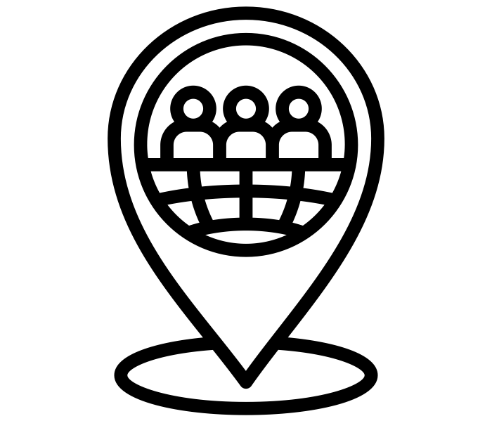 | To know that kings and queens’ rule over people.  To know common themes from stories, such as bravery, difficult choices and kindness, and talk about children’s experiences with these themes. | To know that opening of the first iron bridge was a significant event in our local area.  To know about the life of Samuel Pepys.  To know what London was like in 1666 e.g. jobs, buildings. | To know about the life of the Montgolfier brothers, Wright Brothers, Emilia Earhart, Yuri Gagarin.  To know that there was a space race between the USA and USSR.  Know that the Wright brothers were not the only ones to work on the first human flight, so was Samuel Pierpont Langley. | To know that Homo Sapien (wise man) evolved creatively to  make more complex tools and equipment to farm  To know that the first man was known as a hunter gatherer  To know that Stonehenge is thought of as the world’s most famous prehistoric monument  To know that the Stone Age people were nomads but then became settlers.  To know differences in:  Jobs and Child Employment, Rich and Poor, Schooling.  Migration of population from rural to towns and cities (Industrial Revolution). | To know that ancient civilisations settled near rivers.  To know the religion and gods of Ancient Egypt.  To know the housing and class system of Ancient Egypt.  To know some settlements of the Romans in Britain e.g. major cities, such as London (Londinium), Manchester (Mamucium), Chester and York (Eboracum), as well as Viriconium (Wroxeter). | To know that farming and trade links were established throughout the Maya Region.  To know some Mayan gods and sacrifices, food and diet.  To know some Mayan temples.  To know how Greek towns were arranged.  To know Greek religion, jobs: experiences of men, women, and children, housing and diet. | To know that the name England comes from the Saxon word Angle-Land.  To know some types of housing, diet, religious beliefs e.g. Anglo-Saxon gods and conversion to Christianity.  To know the rulers of Viking times.  To know the Vikings came from Scandinavia (Norway, Sweden and Denmark) on longships and stole gold and jewels from monks in monasteries.  To know many British places were named by the Vikings (the suffix -by coming from the Scandinavian word for  ‘homestead’ or ‘village’.
Vocabulary | family, grandma, grandpa, cousin, mum, dad, brother, sister, past, now, King, queen, bravery, kindness, choices | Life, job, building, | Space race, first flight, discovered, arrived, first | Settlement, city, complex, hunter gatherer, prehistoric, nomads, settlers, monument, tools,  Equipment, Employment, rich, poor, migration, population, rural, town, religion, experiences, housing, diet | Trade links, farming, region, diet, religion, gods, temples | Religion, Gods, ancient, farming, sacrifices, temples. | Religion, gods, ancient, rulers, monk, monastery, longship, village, homestead, Christianity,
Crime and Punishment  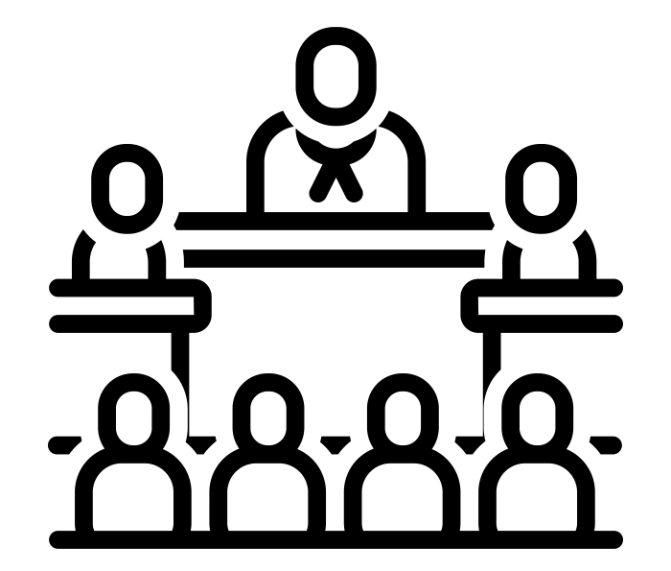 | Employment, rich, poor, migration, population, rural, town, religion, experiences, housing, diet | To know that Robert Hubert was accused of starting the fire at  Thomas Farriner’s bakery in London and was executed. | To know that Charles Darwin was horrified by the treatment of the slaves he encountered on the Beagle voyage.  To know that in 1787 he became a leading member of the Society for the Abolition of the Slave Trade and remained active in anti-slavery reform all his life.  To know that the treatment of slaves was wrong but accepted at the time. | To know that there were no laws in the Stone Age and Iron Age.  To know that Sir Robert Peel established the first police force.  To know about punishments in school. | To know that the Romans used courts and juries.  To know that slaves had no rights.  To know that criminals took part in Gladiator fighting during the Roman times.  To know that grave robbers stole treasure from the tombs of pharaohs. | To know about the creation of Democray and what this mean for the people in Athens.  To know that the city states had different rules the citizens were expected to follow.  To know that the Mayans had strict laws and if a person broke a law they appeared in court where the local leaders or nobles served as judge.  To know that the Maya did not have prisons. Punishment for crimes included death, slavery and fine.  To know that shaving someone’s head was considered a sign of shame. | To know that Anglo-Saxon villages had tithings who were responsible for each other’s behaviour.  To know that Anglo-Saxon criminals were tried in court.  To know that most Anglo- Saxon punishments were carried out in public.  To know the Vikings stole treasures from Monasteries such as Lindisfarne.
Vocabulary |  | Accused, executed | Slave, treatment, accepted, wrong | Established, punishments, | Laws, courts, juries, slaves, rights, criminals, Gladiators, fighting, Robbers, treasure, tombs, stole | Democracy, exile, criminals, tried, court, punishments, public, | Tithings, responsible, behaviour, criminals, tried,  court, punishments, public,
Communication and Invention  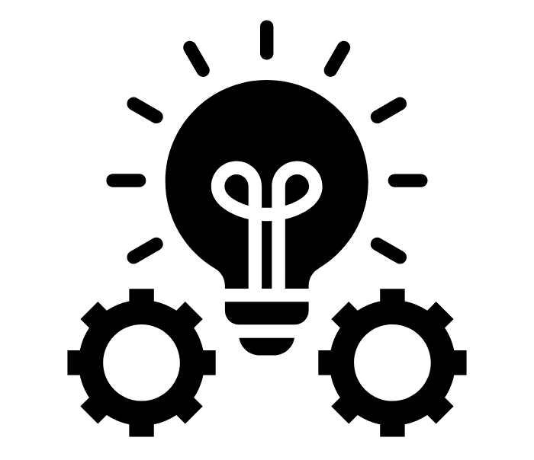 | To know that kings and queens communicated using messengers. | To know that Abraham Darby III was an ironmaster who built the world’s first iron bridge at Ironbridge.  To know that shops and the high street have changed over the years.  To know that the firemen used water buckets filled with river water to put out fires in London.  To know that dynamite and fire hooks were used to destroy buildings to stop the spread of fire in London.  To know that, after the fire, Christopher Wren redesigned the destroyed St Paul’s Cathedral.  To know that Samuel Pepys’ diary recorded the events of the  great fire. | To know that Charles Darwin is known for his theory of evolution, which changed scientific understanding.  To know that Charles Darwin brought back over 1,500 different species from his travels, many of which had never been seen before.  To know that the Wright Flyer was created after 4 years of research and development by the Wright Brothers.  To know that television and radio brought the events of the Moon Landing to a  global audience. | To know that Homo Habilis (skilled man) was the first human to use stone to make tools (hunter- gathers).  To know that the Lascaux cave in France is thought to contain some of the oldest cave paintings in the world.  To know that the Stone/Bronze age brought advancements with weapons, tools, clothing and jewellery e.g. that animal hides were used to make tents, bronze axes were developed which led to advances in woodwork and pottery started to be made.  To know that the steam engine was invented during the Industrial Revolution. | To know about the invention of arenas such as the Colosseum for gladiatorial fights.  To know about armour and protection for the Roman Army.  To know that Romans invented roads and under floor heating.  To know that the Romans built roads in Britain, including the A5.  To know that the Indus Valley civilisation was the first to grow and weave cotton; the Shang Dynasty made beautiful objects out of bronze and the Ancient Sumer civilisation were the first people to develop writing.  To know how the Egyptians used the River Nile to help them farm the land.  To know that Pharaohs were mummified with their things to take with them into the afterlife.  To know that ploughs were attached to oxen to help farmers produce and transport food (Ancient Egypt).  To know that the ancient Egyptians invented Papyrus.  To know that the Sphynx is the oldest known monumental  sculpture. | To know that the Mayans invented the Mayan writing script.  To know that Mayans built pyramids.  To know that Mayans carved calendars out of stone.  To know that the ancient Mayans made cacao into a spicy drink mixed with chilli.  To know that the Olympic games were invented by the Ancient Greeks.  To know that democracy was invented by the Ancient Greeks.  To know that Hippocrates invented medicines and ideas on the human body that are still used today. | To know that the Anglo- Saxon chronicles tell us about life in Anglo-Saxon Britain.  To know that the Vikings invented and used long, swift ships called longships.  To know that the Vikings invented longhouses.  To know that the First World War saw changes to battle strategies, such as the significant use of trenches.  To know that machine guns were a new weapon used in World War 1.  To know that tanks were first used by the British in the Battle of the Somme.  To know that due to changing weapons used in battle new equipment was needed for example gas masks.
Vocabulary | King, queen, messenger, message | Ironmaster, built, iron, bridge, Water buckets, fire service, dynamite, fire hooks, spread, redesign, recorded, diary, | changed, discovered, television, radio, audience, invention | Homo Habilis, tools, hunter gatherer, cave paintings, advancement, hides, woodwork, Steam engine, industry, revolution, | pottery, weapons, axes, tents, gladiator, invention, armour, road, heating, Farm, plough, oxen, produce, transport, invented, papyrus, sculpture, monument, | Chronicle, invented, script, pyramid, calendar, Olympics, ancient, invented, democracy, medicine, body | Longship, longhouse, trenches, machine gun, MG, poison gas, mustard gas, gas mask, tank, Big Bertha

